**CISCO CERTIFICATES**

*NAME :- Nikhil Jatale*

*CLASS :-CS8-59*

*PRN NO:-202401120023*

1)PYTHON ESSENTIAL 1

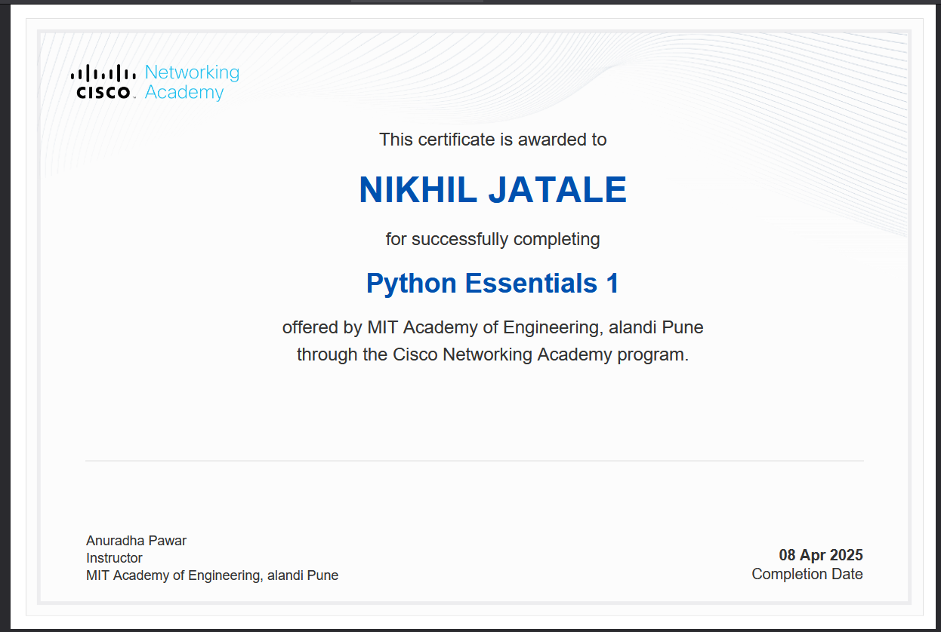

2)PYTHON ESSENTIAL 2

